The title of the presentation

The official languages of the conference are Azerbaijani, Russian and English. An extended abstract must be written in one of these languages. If the abstract is in Russian or Azerbaijani, then you must additionally indicate the title of the presentation in English. The title should be formatted as shown in the first sentence of this template: the first letter is uppercase, the rest are lowercase (except for proper names and abbreviations), a dot is not put at the end

The authors of the presentation should be indicated in the same language as the extended abstract. If the extended abstract in Azerbaijani or Russian, then the authors’ names should be given in English as well. The surname is written first, then the initials follow. For each author, indicate the name of the organization. Presenting author should be denoted by \*. The contact author’s e-mail address should be included.

Example:

Barkly H.G.1\*, Adams A.V.2

1Montanuniversität, Leoben, Austria

2GFZ German Research Centre for Geosciences, Potsdam, Germany

E-mail:

Summary

The number of words in a summary should not exceed 150. If the extended abstract is written in Russian or Azerbaijani, then an abstract and keywords in English should be added (abstract and keywords in English are not included in the scope of the extended abstract). The font for this template is 11pt Times New Roman. The Section Headings are bold. The paragraphs are justified and separated by a blank line. The indent between paragraphs is set to 12 pt. No additional empty lines to fill up the page.

Key words: The number of key words must not exceed 5 words.

Introductiob

This is the first paragraph of the introduction. All styles for this template are formatted for you.

Here is the second paragraph of the introduction. The font for this template is 11pt Times New Roman. The Section Headings are bold. The paragraphs are justified and separated by a blank line.

The font size and style for this template is 11pt Times New Roman. Line spacing is 1. The headings of this section are in bold. Paragraphs are justified. The indent between paragraphs is set to 12 pt. Do not additionally separate paragraphs with blank lines.

Method and / or theory

Additional instructions for writing extended abstracts:

• The text of the abstract can be written in Azerbaijani, English or Russian.

• Authors are responsible for sizing and positioning illustrations.

• Figures can be black and white or color (at least one picture must be included).

• Figures, charts, graphs, equations, etc. and their captions must be embedded into the text.

These bulleted items are used as examples and should be deleted so they do not appear in your document.

Results and discussion

Here is the first sentence of the “Results” section. If you have charts, graphs, equations, etc., then you need to include them in your abstract. You can embed an external file. Below is an example figure.

*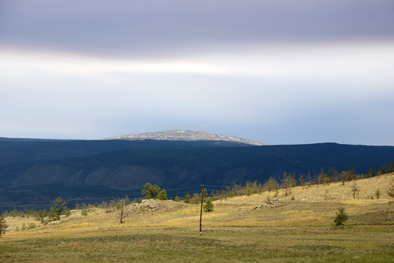*

*Figure 1. This is an example of a figure. Left click on Insert on the menu bar and then select Picture. You can also select to embed an object instead of a picture. You can either embed an existing file or create your object at that point. Number the figures sequentially, according to their appearance in the text, and check that each figure is cited in the text. Supply a short caption for each figure; more detailed discussion of the figure can be reserved for the text. In this template figure captions are 11pt italic Times New Roman.*

Conclusion

Here is the first sentence of “Conclusion” section.

Acknowledgement (Optional)

Your abstract MUST be 4 pages long and MUST contain at least one figure. Font sizes and line spacing should not differ from the template.

References

Here is the first section of the section “References”. Please ensure every citation has a reference and vice versa.

Example:

Serikova, U.S. (2013). Hydrocarbonic resources and prospects of development of oil and gas complex of the Caspian region. Oil and Gas Business, 6, 47-55